

SoundSight.AI

**AI/ML-Powered Insights for Music**

**18th October, 2024**

***Submitted by-***

**Anurag Bhoyar Falguni Gupta Shwetha S**

**Khushi Shapekar Maitreyee Thombrey**

***Abstract***

*This research explores the transformative role of Machine Learning (ML) in the music industry, emphasizing its applications in segmentation, market analysis, forecasting, and business modeling. As the music landscape evolves, ML techniques provide essential tools for understanding listener preferences, identifying market trends, and predicting future performance. By leveraging data-driven insights, ML enables businesses to segment audiences effectively, allowing for targeted marketing strategies that enhance engagement and drive revenue. Additionally, predictive modeling techniques facilitate accurate forecasting of sales and market dynamics, empowering stakeholders to make informed decisions. This study also addresses the ethical considerations surrounding data usage and the implications of algorithm-driven insights.*

1. Introduction

The intersection of Artificial Intelligence (AI) and Machine Learning (ML) with music represents a convergence of art, science, and technology, unlocking new possibilities for musicians, composers, producers, researchers, and music enthusiasts alike. The global AI music market was valued at approximately **$3.9 billion** in 2023 and is projected to grow at a compound annual growth rate (CAGR) of **25.8%**, reaching **$38.71 billion** by 2033​ ([Source](https://market.us/report/ai-in-music-market/)).In India, the music industry is rapidly expanding, with the overall music market expected to reach **$1.5 billion** by 2025, driven largely by digital streaming services and a growing base of internet users​. ([Source](https://rareconnections.io/ai-music-statistics/))

This project focuses on utilizing data-driven approaches for segmentation, market analysis, financial modeling, and forecasting. By employing these methods, we can gain valuable insights into consumer behavior and industry trends, which are critical for decision-making in the music sector. This approach will facilitate a better understanding of audience preferences, allowing artists and labels to optimize their strategies for reaching their target markets effectively.

This project, **SoundSight AI**, aims to leverage ML techniques for segmentation, market analysis, and forecasting in the music industry. By providing actionable insights into listener preferences and market trends, this tool will fill a critical gap in data-driven decision-making for artists and labels. As the industry increasingly relies on analytics to optimize marketing strategies and improve audience engagement, **SoundSight AI** will empower stakeholders to make informed choices, ultimately enhancing their ability to thrive in a rapidly evolving music landscape.

* 1. Problem Statement

The modern music industry faces significant challenges in effectively understanding audience preferences and leveraging data for strategic decision-making. Despite the abundance of data generated from streaming platforms and social media, many artists and labels struggle to interpret this information in a way that can inform business strategies such as market segmentation, pricing, and promotional efforts.

For independent artists and smaller music labels, the challenge is amplified by financial instability; many of these musicians earn minimal revenue from streaming, with reports indicating that artists receive as little as $0.004 per stream on major platforms​. This low payout model, combined with a highly competitive landscape, necessitates a more sophisticated approach to understanding market trends and audience behaviors. Without actionable insights, artists may miss opportunities for targeted marketing and audience engagement, impacting their ability to sustain their careers in an evolving industry.

* 1. Project Objectives

This project, **SoundSight AI**, aims to address the following critical gaps within the music industry:

1. **Data-Driven Market Segmentation**: Utilize machine learning techniques to segment audiences based on various parameters, including listening habits, genre preferences, and geographic locations. By identifying distinct audience segments, artists and labels can tailor their marketing strategies and promotional activities to effectively reach their target markets.
2. **Forecasting Market Trends**: Develop predictive models using historical data and emerging trends to forecast changes in music consumption and audience preferences. These insights will empower artists and labels to make informed decisions regarding music releases, promotional campaigns, and collaborations.
3. **Revenue and Financial Modeling**: Create a financial equation to help artists and labels estimate potential revenue based on factors like streaming numbers, merchandise sales, and live performances. This model will aid in simulating various financial scenarios, allowing stakeholders to plan for sustainable growth and optimize their business strategies.
4. **Prototype Selection**

**Prototype Idea: SoundSight AI – AI-Powered Music Insights Platform**

**2.1. Feasibility**

SoundSight AI can be developed within the next 2-3 years. The core components of the platform involve leveraging existing machine learning techniques for market analysis and revenue forecasting. Given the availability of various data sources, including streaming analytics and social media metrics, the technical feasibility is high. Additionally, the development team can build a Minimum Viable Product (MVP) to test the market within this timeframe.

**Key Considerations:**

* Access to music streaming data and analytics.
* Collaboration with music industry stakeholders for data gathering.
* Utilizing existing machine learning libraries and frameworks.

**2.2. Viability**

The relevance of SoundSight AI extends well into the next 20-30 years. As the music industry continues to evolve with digital transformation, the demand for data-driven insights will only increase. Independent artists and labels will increasingly seek tools to understand audience behavior, optimize their marketing efforts, and forecast trends. SoundSight AI will be positioned as an essential tool for navigating the complexities of the modern music landscape, ensuring its long-term viability.

**Key Considerations:**

* Continuous updates to adapt to changes in music consumption patterns.
* Incorporating new features based on user feedback and industry trends.
* Potential expansion into adjacent markets (e.g., video content, podcasting).

**2.3. Monetization**

SoundSight AI will implement a direct monetization strategy through subscription-based pricing tiers for artists, labels, and music marketers. Different subscription plans can offer varying levels of access to features, such as advanced analytics, forecasting tools, and personalized market reports. Additionally, partnerships with music industry platforms could open up opportunities for revenue sharing through integrated services.

**Key Considerations:**

* Pricing strategies based on user segments (independent artists vs. major labels).
* Potential for additional revenue streams through affiliate marketing or partnerships.
* Offering tiered services (basic, professional, and enterprise) to capture a wide range of users.

1. Prototype Development

**3.1 Data Input**:

* + The dataset used in this project includes key metrics from music streaming platforms, such as track popularity, genre trends, and listener demographics. These features will serve as the foundation for market segmentation and revenue forecasting models.
  + **Additional Data Sources**: The dataset can be enriched by incorporating publicly available information from social media trends, music reviews, and industry reports, enabling a more comprehensive analysis of audience preferences.
  1. **Model Building**:
  + 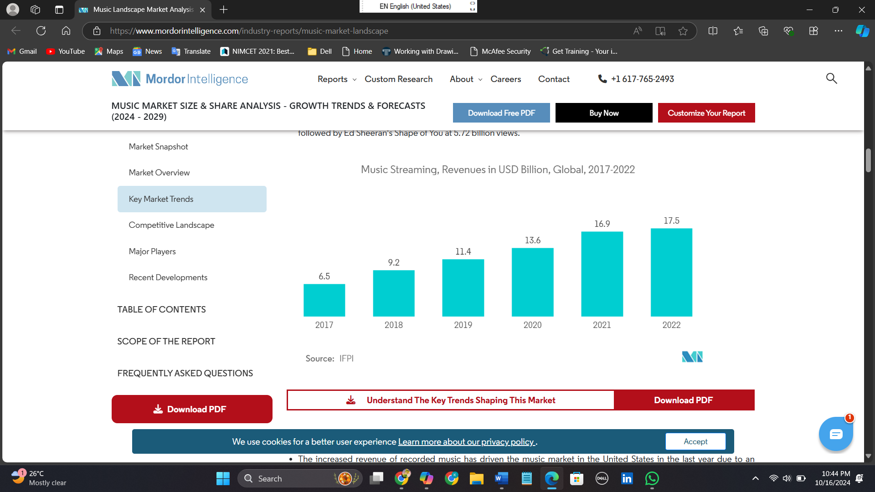**Segmentation and Trend Analysis**: We will employ clustering algorithms to group listeners based on their genre preferences and listening habits. This segmentation will help identify emerging trends and niche markets, enabling more targeted marketing strategies.
  + **Revenue Prediction**: A regression model will be developed to predict potential revenue based on factors such as track popularity and listener engagement. This model will assist artists and labels in simulating various business scenarios.
  + **Forecasting**: Time-series forecasting models will be used to predict future market trends and audience preferences. This will provide actionable insights to optimize marketing strategies and maximize engagement.

1. Business Modelling

**4.1. Value Proposition:**

The core value of **SoundSight AI** is its ability to provide actionable, data-driven insights for independent artists, small labels, and music marketers. Unlike larger platforms designed for major labels, this tool offers personalized analytics at an affordable cost, specifically tailored to smaller-scale stakeholders. Key features include:

* **Music trend insights**: Analyzing genre popularity and listener demographics
* **Predictive analytics**: Forecasting track success and audience engagement
* **Marketing strategy optimization**: Tailored recommendations for promoting music and increasing streams

**4.2. Target Market:**

* **Primary Market**: Independent musicians, small labels, and music marketers who require affordable and accessible insights to optimize their music releases.
* **Secondary Market**: B2B clients, including music streaming services, digital marketing agencies, and music distribution platforms.

**4.3. Revenue Streams:**

* **Subscription-based pricing model**: **SoundSight** **AI** will offer tiered subscription plans, including:
  + **Freemium Tier**: Basic access to general insights (e.g., genre trends and engagement metrics)
  + **Premium Tier**: Advanced analytics (e.g., revenue prediction, detailed segmentation reports, and customized marketing insights)
  + **Enterprise Tier**: Tailored for larger clients, offering complete API access and premium support services.
* **Consultancy Services**: Offer personalized consultancy for users requiring deeper analysis or strategy sessions.
* **Data Licensing**: Monetize aggregated data insights by licensing it to music industry stakeholders, such as streaming platforms or music marketers.

**4.4. Key Partnerships:**

To ensure comprehensive data access and enhance platform capabilities, **SoundSight AI** will establish partnerships with:

* **Music streaming services**: Platforms like Spotify, Apple Music, and Tidal to access detailed streaming data.
* **Social media platforms**: Partner with Instagram, Twitter, and TikTok for social media data aggregation and sentiment analysis.
* **Artist support organizations**: Collaborate with independent artist support groups and industry platforms to widen the user base and enhance community participation.

**4.5. Cost Structure:**

The main costs associated with **SoundSight AI** will include:

* **Development Costs**: Building and maintaining the platform’s data processing, analytics, and machine learning models.
* **Cloud Infrastructure**: Costs associated with hosting data and running models on cloud services like AWS or Azure.
* **Marketing and Customer Acquisition**: Expenses for acquiring new users through partnerships, social media campaigns, and digital marketing.
* **Customer Support**: Provision of premium customer support services, especially for enterprise-tier users.

**4.6. Channels:**

* **Direct Sales**: Targeted at small labels and independent artists through the platform’s website and app.
* **Partnerships**: Use collaborations with artist management platforms and music marketing agencies to reach a broader audience.
* **Digital Marketing**: Leverage social media advertising, content marketing, and influencer partnerships to attract smaller artists and marketers

**5. Financial Modelling**

**5.1. Market Identification**

The financial model for **SoundSight AI** targets the independent music market and small record labels, sectors experiencing steady growth due to the rise of streaming platforms like Spotify, Apple Music, and Bandcamp. As of 2021, the independent music market was valued at **$1.2 billion**, with a projected Compound Annual Growth Rate (CAGR) of **6%** over the next five years. **SoundSight AI** will initially focus on regions with high music streaming activity, such as North America, Europe, and parts of Asia, where the demand for data-driven insights is strong among independent artists and small labels.

**5.2. Revenue Forecasting**

Utilizing time-series forecasting and regression models, **SoundSight AI** will project future revenues based on expected market growth. By analyzing subscription trends and industry growth, we can estimate how many premium users will subscribe to the platform and their potential contribution to overall revenue. This predictive model will help determine how fast the platform can scale and what factors contribute most to profitability.

**5.3. Financial Equation for the Platform**

The platform’s primary revenue stream comes from its subscription-based model. For the premium service, **SoundSight AI** charges **Rs. 500 per month**. Operating costs, including server maintenance, marketing, and other overheads, are **Rs. 20,000 per month**.

The financial equation is structured as:

Revenue(y)=500x−20,000

Where:

* y represents the total monthly revenue.
* x is the number of premium users.

For example, if there are **200** premium users in a given month:

y=500×200−20,000=100,000−20,000=80,000Rs.

This model allows flexibility in projecting different financial outcomes by adjusting the subscription fee or number of users, giving insight into the platform’s profitability.

**5.4. Revenue Streams Considered**

**SoundSight AI** generates revenue through multiple channels:

1. **Subscription Revenue**:
   * **Freemium Model**: Basic features are available for free, with premium features unlocked via subscription.
   * **Premium Subscriptions**: Users gain access to advanced analytics and forecasting tools.
2. **Data Licensing**:
   * Aggregated reports and insights can be sold to third-party platforms like streaming services, enhancing their business analytics offerings.
3. **Consultancy Services**:
   * Artists or labels can request customized reports or strategic consultancy services for a fee, adding an additional revenue stream.

**5.5. Financial Equation for Revenue Forecasting**

To estimate revenue for artists and labels using the platform, the following formula incorporates various revenue streams:

Total Revenue=(Streams×Payout per Stream)+(Merchandise Sales×Profit per Item)+(Ticket Sales×Average Ticket Price)

Where:

* **Streams** are the total number of plays on platforms like Spotify or Apple Music, with payouts ranging from $0.003 to $0.005 per stream.
* **Merchandise Sales** are additional revenue sources, with profits calculated as the sale price minus production costs.
* **Ticket Sales** include concert or live event revenue, along with exclusive concert merchandise sales.

**5.6. Simulating Financial Scenarios**

By adjusting variables in the financial model, **SoundSight AI** can simulate different business scenarios:

* **Best-Case Scenario**: High streaming engagement, strong merchandise sales, and sold-out live events.
* **Worst-Case Scenario**: Low streaming numbers, poor merchandise sales, and canceled or under-attended concerts.
* **Moderate Growth Scenario**: Steady, modest performance across all revenue streams, allowing for gradual business growth.

These simulations will enable independent artists and small labels to make informed decisions, plan for different market conditions, and optimize their revenue generation strategies.

* 1. **Exploratory Data Analysis (EDA)**

The goal of this step is to conduct an in-depth analysis of the dataset to better understand the underlying trends, relationships, and patterns in the data. This analysis will guide the dimensionality reduction and clustering techniques applied later to identify distinct market segments for targeting purposes. Below, we outline the key stages of the EDA process, covering statistical exploration, correlation analysis, and clustering insights.

**6.1 Data Overview**

We begin by analysing the structure of the dataset, identifying key numerical features such as **popularity**, **danceability**, **energy**, **loudness**, **acousticness**, and **tempo**. The data was standardized to ensure consistent scaling across different features, which is crucial for accurate clustering results.

Key steps in the EDA include:

* **Data Types and Missing Values**: Identified numerical and categorical data columns and addressed missing values to ensure data integrity.
* **Descriptive Statistics**: Generated summary statistics (mean, median, standard deviation) for the numerical features, helping to identify skewness and the presence of outliers.

**6.2 Distribution Analysis and Outliers**

Using histograms and density plots, we analyzed the distribution of key numerical features. This revealed:

* **Right-Skewed Distributions**: Features such as **popularity**, **energy**, and **loudness** displayed right-skewed distributions with longer tails toward higher values.
* **Outliers**: Some variables, particularly **loudness** and **energy**, showed the presence of outliers, especially in the right tails of their distributions.

This step provided essential insights into the variability of the dataset, influencing feature selection for clustering and segmentation.

**6.3 Correlation Analysis**

To explore relationships between the numerical features, a heatmap was generated showing the correlations between attributes such as **danceability**, **energy**, **loudness**, and **popularity**. Key findings include:

* Strong positive correlation between **energy** and **loudness**.
* Moderate correlations between **popularity** and **danceability**, suggesting that more danceable tracks tend to be more popular.

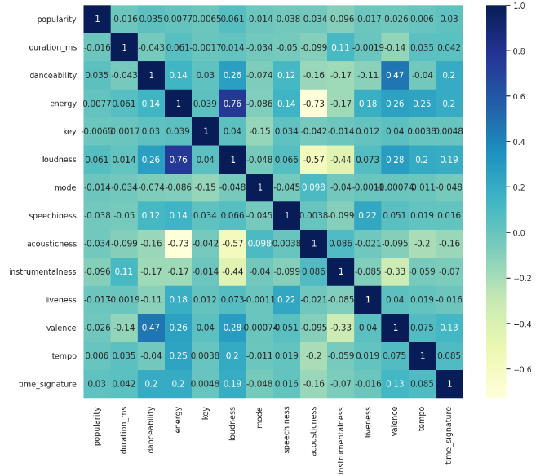

**6.4 Categorical Features Analysis**

Using count plots, we examined the distribution of key categorical variables such as **genre**, **explicitness**, **key**, and **time signature**. Key insights include:

* **Genre Distribution**: Pop and dance music were dominant in the dataset.
* **Top 10 Genres by Count**: Visualized the most frequent genres, which provided insights into the popularity of certain music styles.

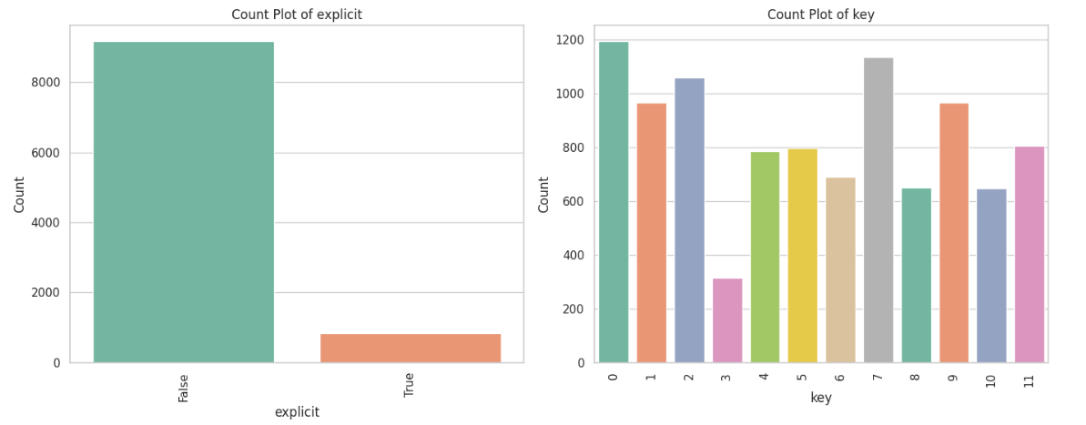

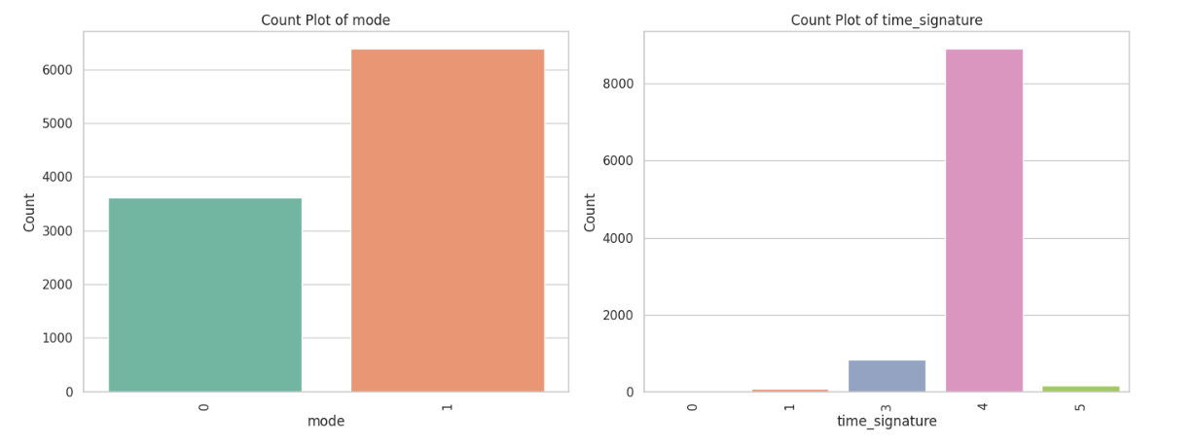

**6.5 Genre-Based Popularity Analysis**

To further explore genre trends, we aggregated the data by **genre** and analyzed the total popularity of each genre. This analysis revealed that:

* The top 15 most popular genres contribute significantly to the overall engagement of songs, with specific genres such as **pop**, **hip-hop**, and **electronic** leading the pack in terms of cumulative popularity.

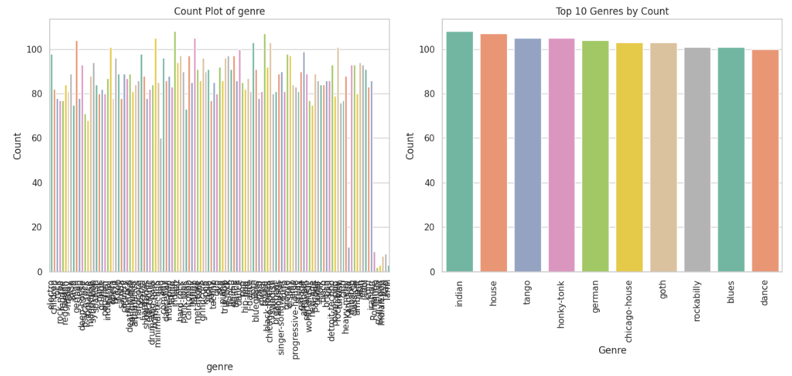

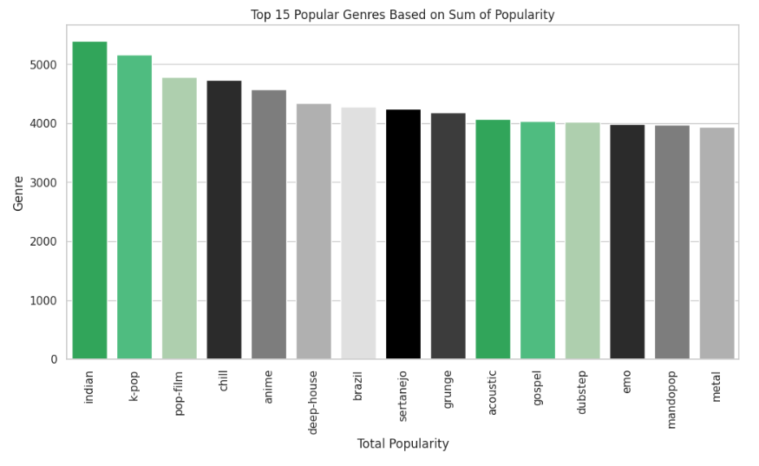

**6.6 Artist Popularity and Track Count**

In addition to genre analysis, we grouped the data by **artist** to identify which artists had the highest number of tracks and the most cumulative popularity. This revealed that:

* **Top 15 Artists by Track Count**: Some artists dominate the dataset by sheer number of tracks, while others have fewer but highly popular songs.
* **Top 15 Artists by Popularity**: The cumulative popularity of songs by specific artists showcases their influence in the dataset.

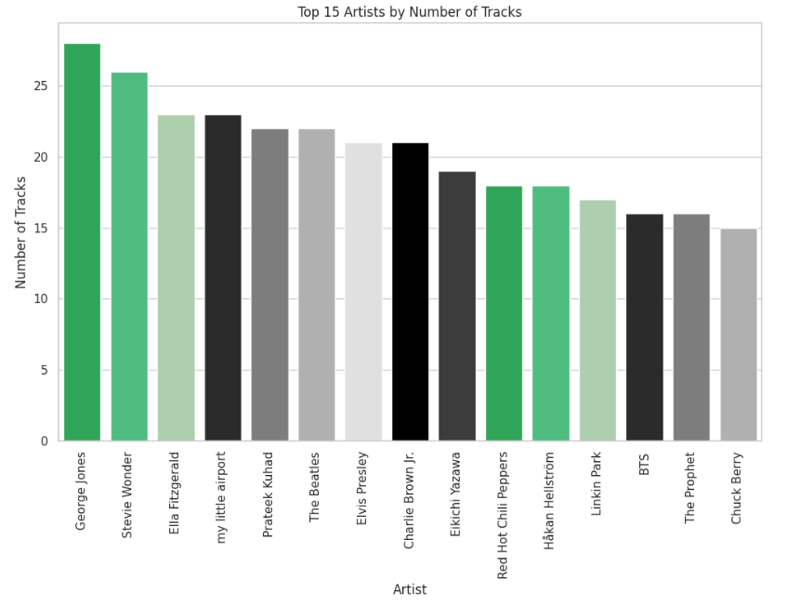

* 1. Dimensionality Reduction with PCA

Principal Component Analysis (PCA) was employed to reduce the dimensionality of the dataset while retaining 95% of the variance. By transforming the dataset into two principal components, we ensured that key information was preserved while simplifying the dataset for clustering.

* **PCA Results**: The two principal components extracted from the data captured the majority of the variance, making it easier to visualize the dataset in two dimensions.
* **Benefits of PCA**: Dimensionality reduction allows us to focus on the most important aspects of the data without losing critical information, which is essential for generating meaningful clusters in the next step.
  1. K-Means Clustering and Target Market Segmentation

K-Means clustering was applied to group songs into distinct clusters based on their shared characteristics. After determining the optimal number of clusters using the **Elbow Method** and analysing **Silhouette Scores**, we segmented the dataset into three clusters.

**8.1 Cluster Analysis**

Each cluster represents a unique market segment based on specific audio features:

* **Cluster 0: Mainstream Pop Segment**
  + **Key Features**: High energy (0.79), high tempo (133.76 BPM), and low acousticness (0.09).
  + **Target Audience**: Listeners who prefer high-energy, mainstream tracks. Ideal for workout, EDM, and party playlists.
* **Cluster 1: Acoustic, Low-Energy Niche**
  + **Key Features**: High acousticness (0.75), low energy (0.28), and slower tempo (108.63 BPM).
  + **Target Audience**: Fans of acoustic or folk music, suitable for relaxation or study playlists.
* **Cluster 2: Danceable, Balanced-Energy Songs**
  + **Key Features**: High danceability (0.66), moderate energy (0.71), and balanced tempo (120.89 BPM).
  + **Target Audience**: Mainstream pop and dance music fans, perfect for general listening, fitness, or casual party playlists.

**8.2 Cluster Visualization**

To visualize the clusters, we plotted the first two principal components, highlighting how the songs grouped into distinct clusters based on their audio features. This provides a clear understanding of the segmentation and supports targeted marketing strategies.

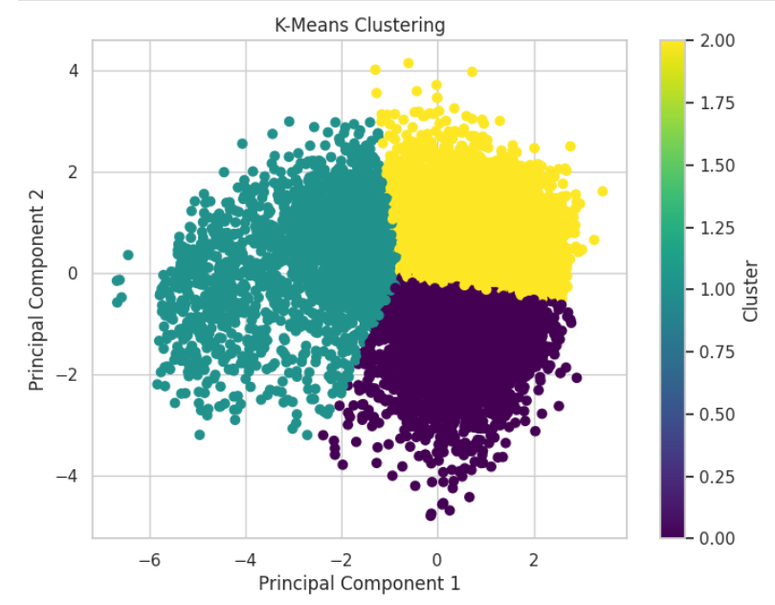

**Conclusion**

Through exploratory data analysis, dimensionality reduction, and clustering, we successfully segmented the dataset into three distinct music market segments. These clusters allow artists, producers, and marketers to tailor their promotional efforts to specific listener preferences, increasing engagement and maximizing the impact of their content.

* **Cluster 0**: High-energy, mainstream songs for gym-goers, EDM lovers, and party enthusiasts.
* **Cluster 1**: Low-energy, acoustic tracks for relaxation, study playlists, and folk music fans.
* **Cluster 2**: Danceable, balanced-energy songs for mainstream pop listeners and general audiences.

By understanding these segments and targeting each group with customized marketing strategies, stakeholders can optimize their reach and engagement in the music industry.

**Contributors**

This project was a team effort, and we acknowledge the contributions of all members.

You can explore their work on GitHub:

**Anurag Bhoyar:** [github.com/Freakybhoyar/](https://github.com/Freakybhoyar/Feynn_Labs/tree/main/Indian%20EV%20Market%20Analysis)

**Falguni Gupta:** [github.com/GuptaFalguni/](https://github.com/GuptaFalguni/McDonalds_-Market_Segments)

**Shwetha S:** [github.com/Shwetha-5/](https://github.com/Shwetha-5/EV-market-analysis/tree/main)

**Khushi Shapekar:** [github.com/Khushishapekar/](https://github.com/Khushishapekar/Feynn-Labs/tree/main/EV%20Market%20Analysis)

**Maitreyee Thombrey:** [github.com/mthombrey/](https://github.com/mthombrey/Feynn-Labs)